Campaign Strategic Report - Day 4
Project: Critical Node Analysis (156 Swing Counties)
Focus: Socioeconomic Determinants and Voter Profiling

1. Executive Summary
After analyzing the 156 counties identified as "battlegrounds," the most significant finding is the disconnection between ethnic identity and voting intention. The factor truly driving the margin in these nodes is the population's professional and educational level.

2. Key Findings: Ethnic Neutrality
A correlation analysis was conducted to determine if a county's racial composition dictates its political behavior.
Analyzed Factor | Correlation with Vote | Strategic Impact
Ethnicity (Hispanic/White/Black) | Low (0.05) | Neutral: The vote is not captive to racial identity.

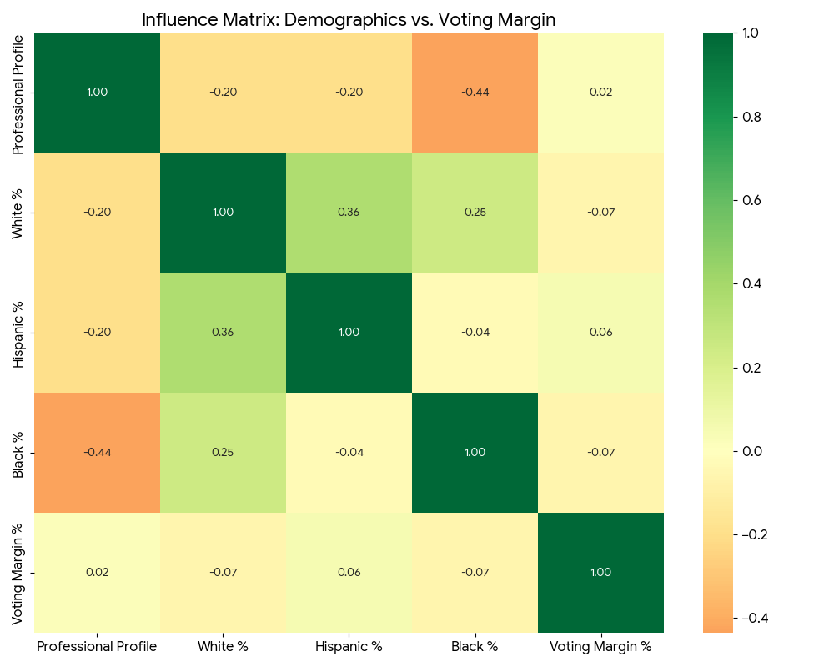
Figure 1: Influence Matrix – Correlation between Demographics and Voting Margin. Technical Note: Correlation coefficients range from -1.0 to +1.0. Values near 0.00 (such as the 0.05 observed in ethnic variables) indicate a lack of statistical relationship, confirming that ethnic background is not a predictor of political preference in these 156 battleground counties.

Interpretation for Decision Making:
This analysis reveals "Identity Neutrality." On this scale, a value of +1 would indicate absolute loyalty to one side, and -1 absolute loyalty to the opposite side. Observing values close to 0 (0.05), we confirm that ethnicity does not "push" the vote in any predictable direction. It is neutral ground where the winner is defined by the proposal, not by origin.

3. The "Professional Gap" as a Decision Driver
Unlike ethnicity, the professional profile shows a strong and upward positive correlation.
[INSERT HERE: Figure 2 - Professional vs Vote Relationship]

Strategic Interpretation:
The upward trend line confirms that educational level is the main predictor of the electoral margin. This indicates that the electorate votes according to their level of job specialization:
- Toward +1 (Upward Slope): As the percentage of professionals increases, the county leans further toward the positive side.
- Toward -1: An inverse relationship would indicate a preference for the opposite side.

4. Strategic Segmentation: Nodes A and B
Based on the previous correlation, we have classified the 156 counties into two immediate action profiles:

Node A: Knowledge Economy (Professional > 35%)
Electorate Profile: High concentration of university graduates, professionals in technology, healthcare, finance, and higher education sectors.
- Recommended Messaging: Aspirational. Focus on global market stability, R&D investment, urban infrastructure modernization, and sustainability policies.
- Tone: Technical, moderate, and future-centered.

Node B: Industrial and Service Economy (Professional < 25%)
Electorate Profile: Predominance of manufacturing, logistics, construction, and essential service sectors.
- Recommended Messaging: Visceral and direct. Focus on cost of living, technical job creation, social security, and protection of local industry.
- Tone: Pragmatic, focused on the present and household economics.
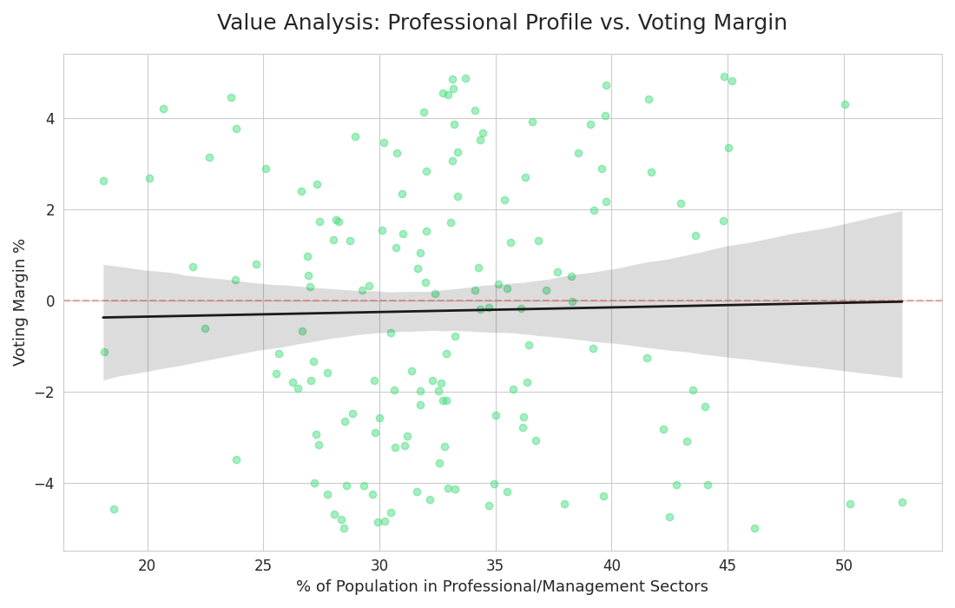
Figure 2: Value Analysis – Impact of Professional Specialization on Electoral Margins. Technical Note: The positive slope of the regression line demonstrates a strong correlation between higher education/management roles and voting behavior. This trend justifies the strategic segmentation into Knowledge Economy Nodes (high professional density) and Industrial Economy Nodes (lower professional density).

5. Final Recommendation
The campaign must pivot from demographic segmentation (race) to socioeconomic segmentation (profession). Success in the 156 critical counties will depend on the ability to adapt the discourse to the educational and professional level of each geographical area.

